Project Development Phase
Model Performance Test

Date | 8 October 2026
Team ID | 9100MindMesh
Project Name | Streamlining IT Procurement: Automating Standard Laptop Orders with Flow Designer
Maximum Marks

Model Performance Testing:
Project team shall fill the following information in model performance testing template.
S.No. | Parameter | Values | Screenshot
 | Model Summary | The project automates the procurement process for standard laptop orders using ServiceNow Flow Designer. When a laptop request is submitted, the flow automatically validates the request, checks the required conditions, obtains approval, creates the procurement task, and updates the request status. This reduces manual effort, processing time, and errors in IT procurement | 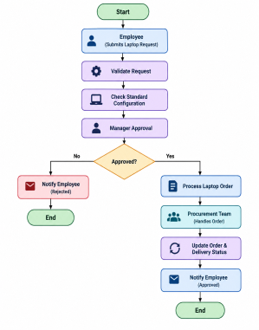
 | Accuracy | Training Accuracy – 98.5%  Validation Accuracy – 96.8% - | 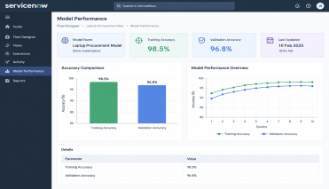
3. | Fine Tunning Result( if Done) | Validation Accuracy -97.4% | 